Project Planning Phase

SPRINT-3

|  |  |
| --- | --- |
| Date | 9 November2022 |
| Team ID | PNT2022TMID04739 |
| Project Name | IOT BASED SAFETY GADGET FOR CHILDMONITORINGAND NOTIFICATION |

USN1: As a user I need to enroll the cloud registration

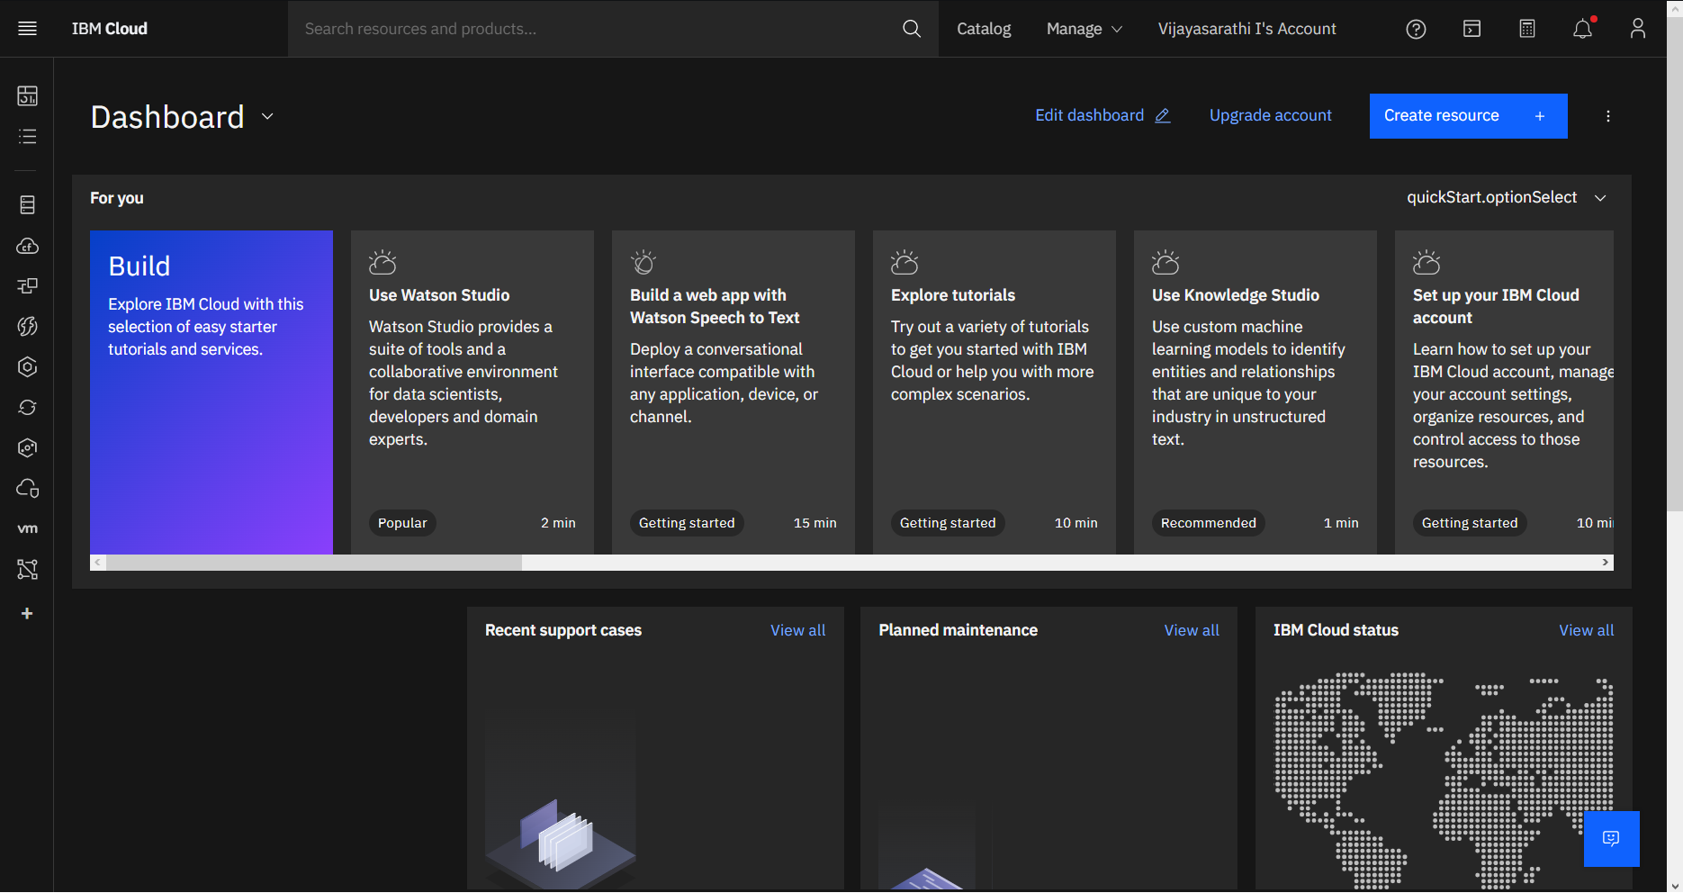

USN2: After creating cloud account launch IBM Watson IOT platform by accessing cloud account

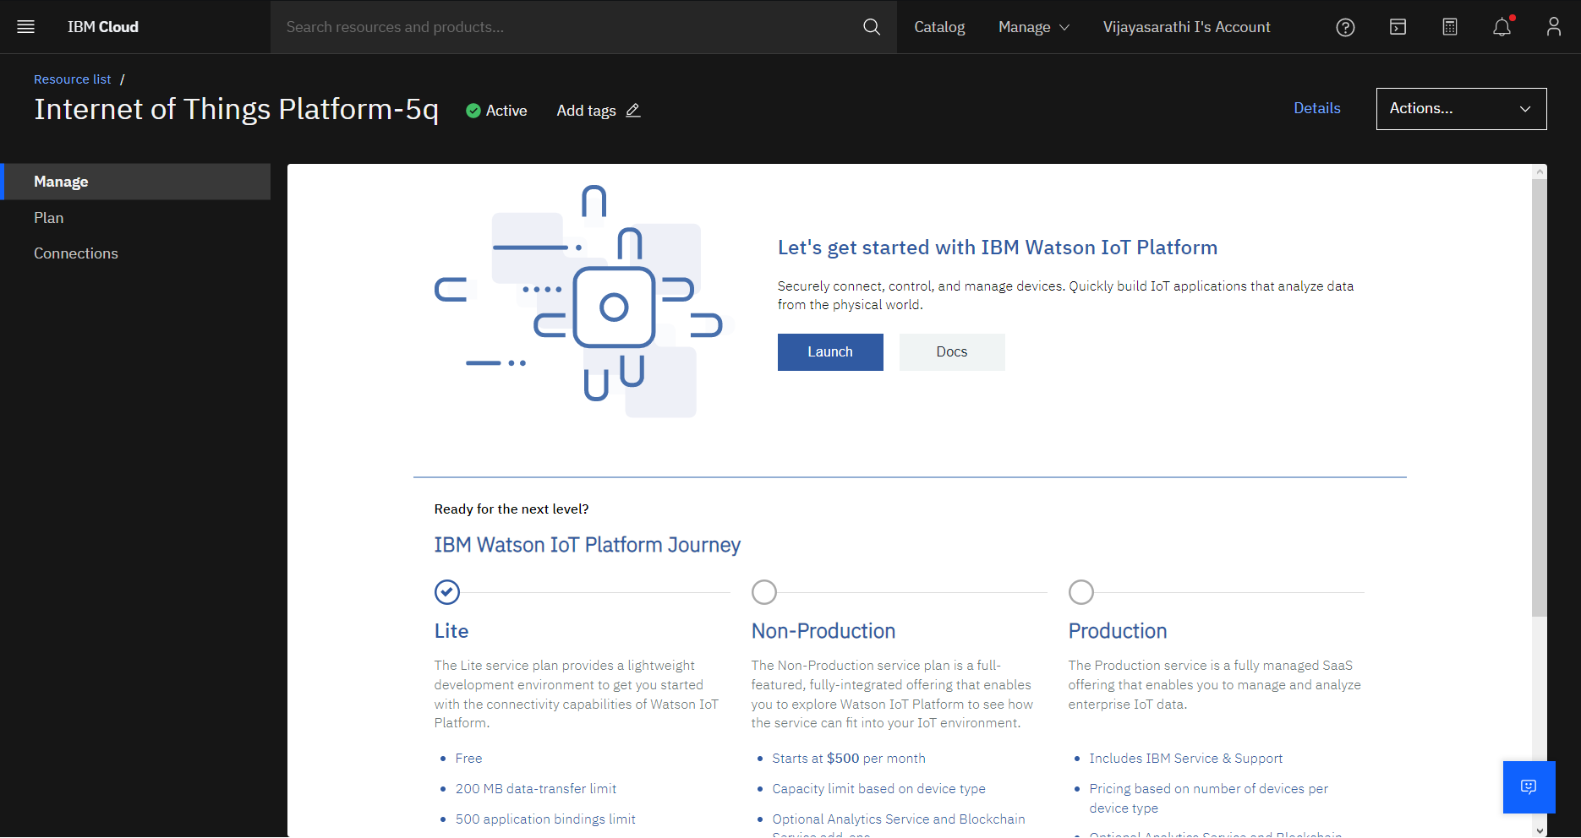

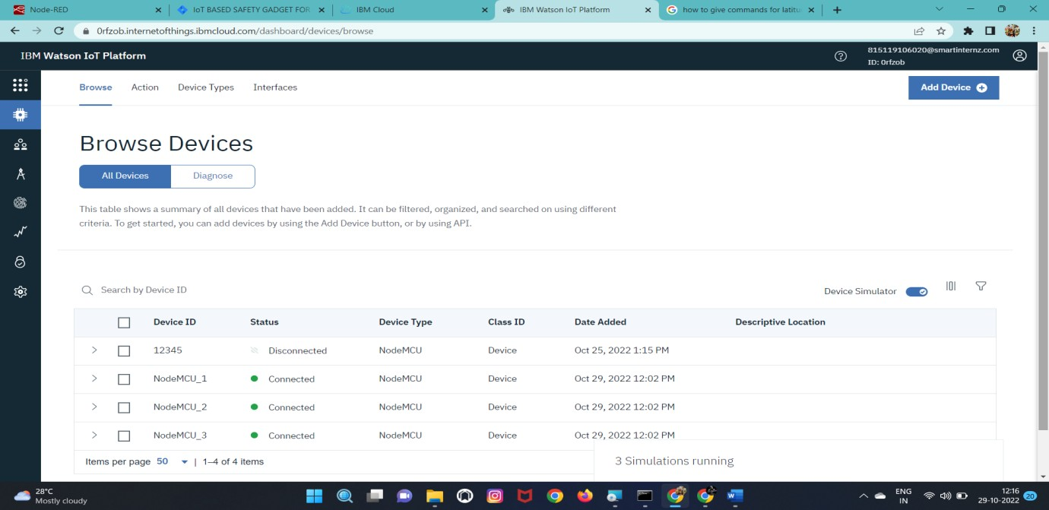USN3: Create the node in IBM Watson platform

USN4: After Creating node get device Type and id

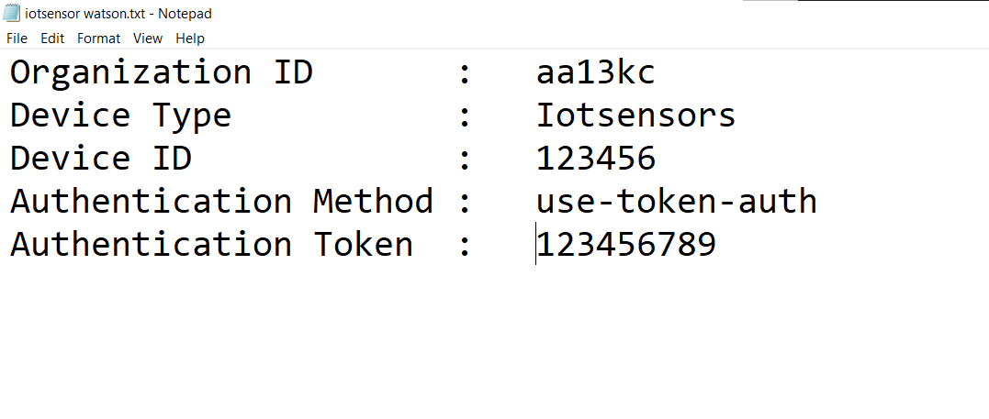

USN6: Simulate the node created

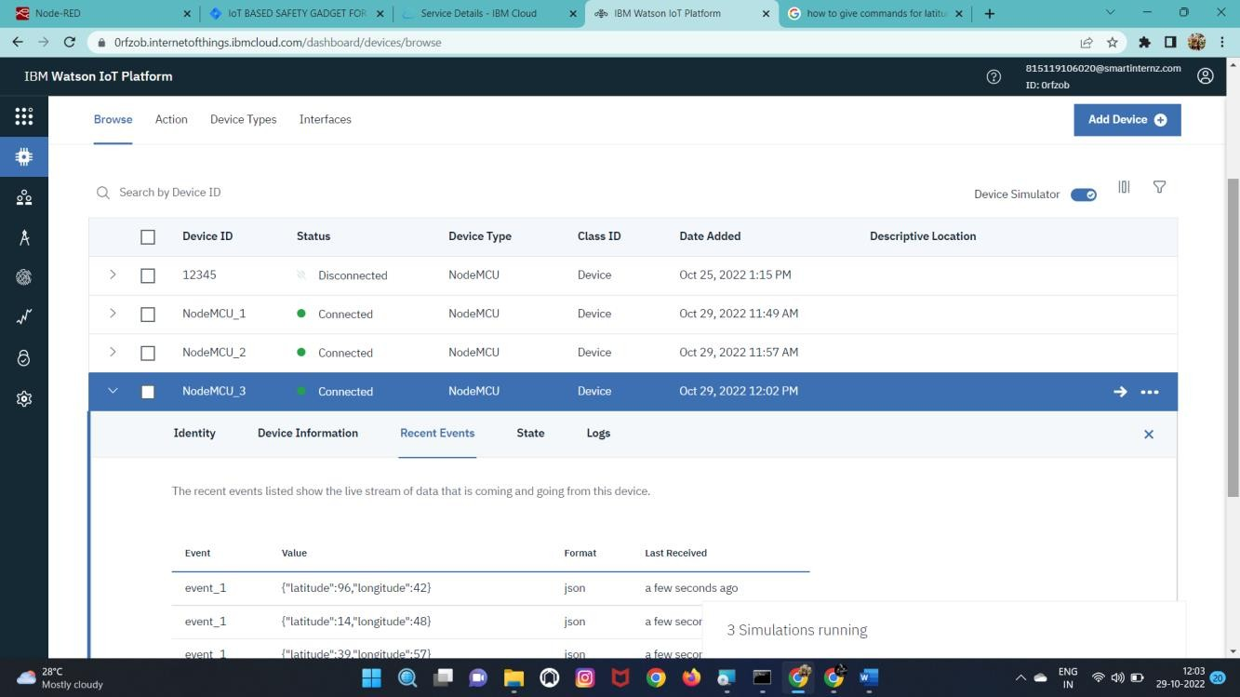

# BURNDOW NCHART:

# 

# VELOCITY CHART:

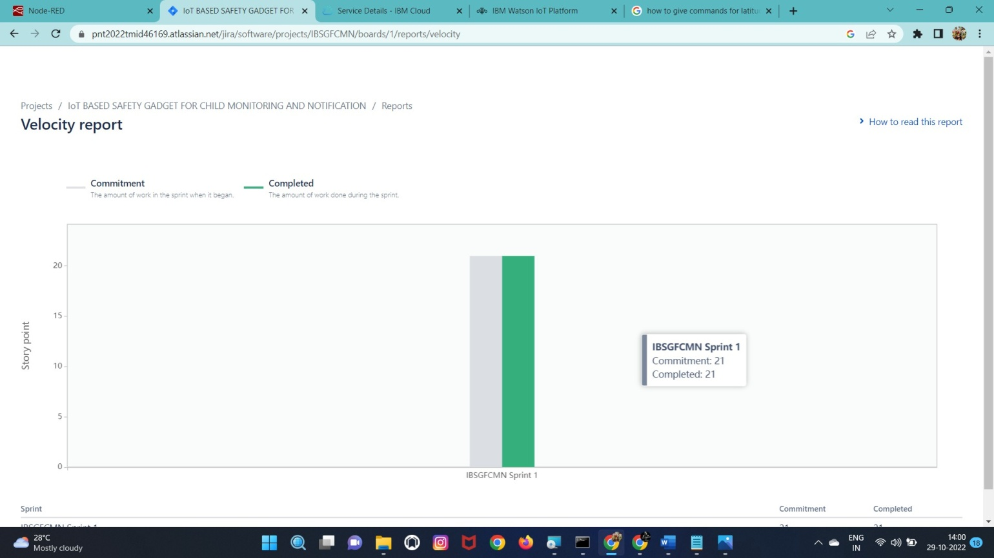

# ROAD MAP:

